

Lab Experiment – 04
Crypt-Arithmetic Problem

Aim
To solve the Crypt-Arithmetic problem using the Backtracking algorithm.

Objective
To find digit assignments to letters in an arithmetic puzzle such that the mathematical equation is satisfied.

Algorithm
- Read the Crypt-Arithmetic puzzle.
- Extract all unique letters from the puzzle.
- Check whether the number of unique letters is less than or equal to 10.
- Assign digits (0–9) to the letters without repetition.
- Ensure that the leading letter of each word is not assigned the digit 0.
- Evaluate the arithmetic expression using the assigned digits.
- If the equation is satisfied, display the solution.
- Otherwise, backtrack and try another digit assignment.
- Repeat until a valid solution is found or all possibilities are exhausted.

FlowChart
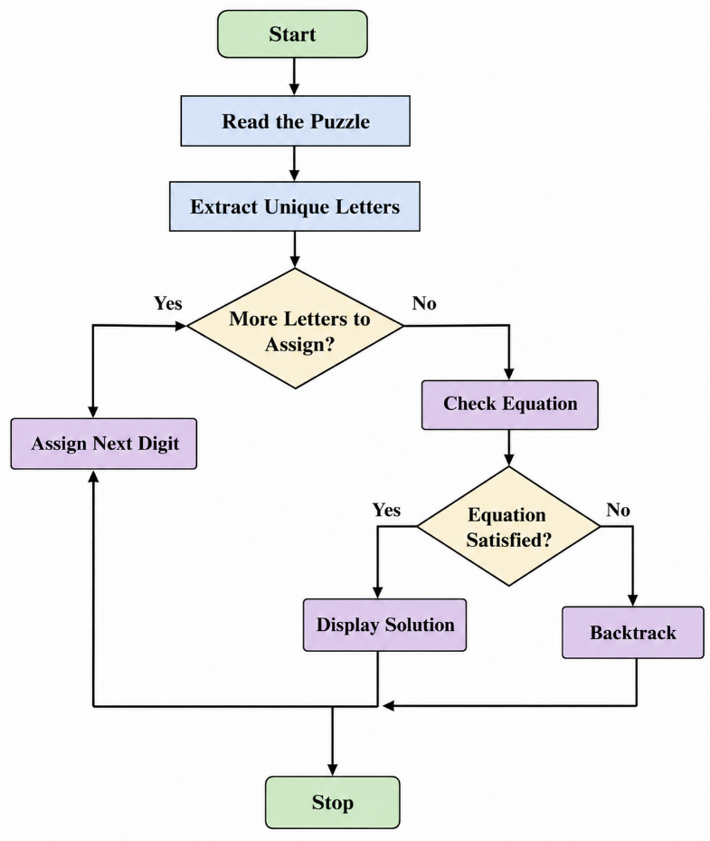
Code:
from itertools import permutations

letters = ('S', 'E', 'N', 'D', 'M', 'O', 'R', 'Y')

for p in permutations(range(10), len(letters)):
d = dict(zip(letters, p))

if d['S'] == 0 or d['M'] == 0:
continue

send = 1000*d['S'] + 100*d['E'] + 10*d['N'] + d['D']
more = 1000*d['M'] + 100*d['O'] + 10*d['R'] + d['E']
money = (10000*d['M'] + 1000*d['O'] +
100*d['N'] + 10*d['E'] + d['Y'])

if send + more == money:
print("Solution Found:")
print(d)
print("SEND =", send)
print("MORE =", more)
print("MONEY =", money)
break
Output
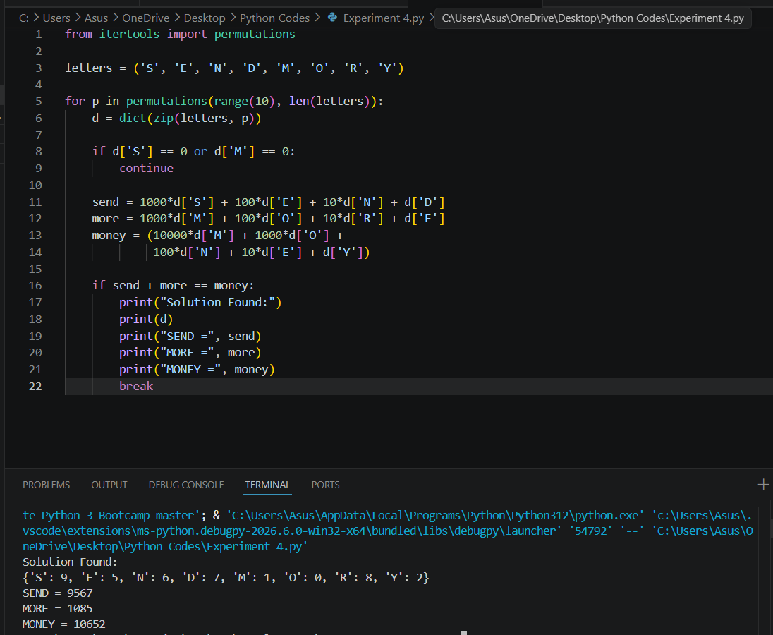

Result
The Crypt-Arithmetic problem was solved successfully using the Backtracking algorithm.

Conclusion
The program successfully assigns unique digits to letters and verifies the arithmetic equation. Backtracking ensures that all possible assignments are explored until a valid solution is found.

